

**network topology in packet tracer**

**CSE1004(NETWORK AND COMMUNICATION)LAB:L53-L54**



**January 26, 2022**

**ANIRUDH VADERA**

**20BCE2940**

**QUESTION:**

**Create different types of Network Topology in Cisco Packet Tracer.**

**DESCRIPTION:**

**Getting started:**

* **Open your packet tracer and first login through your Netcad credentials:**

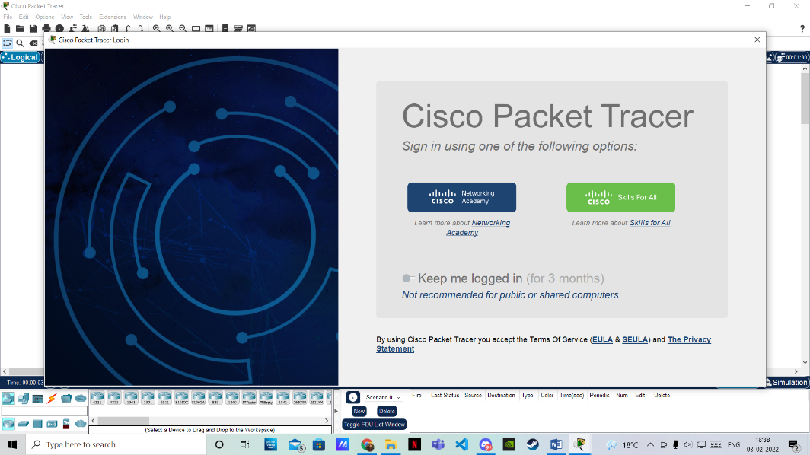

* **Adding Pcs in Cisco Packet Tracer:**

To add PCs in Cisco Packet Tracer, you need to perform the following steps:

1. In the Cisco Packet Tracer console, click on the PC icon, click Generic, and then click in the logical view area to add a Generic PC.
2. Repeat the same step to add three more Generic PCs in the logical view area, as shown in the following figure.

* **Adding Swicthes in Cisco Packet Tracer:**

1. To add a switch in Cisco Packet Tracer, click the Switch icon, select a switch type, such as 2960, and then add the selected switch in the logical view area.
2. Repeat the same step to add one more switch.

* **Connection Types in Cisco Packet Tracer:**

To connect devices in Cisco Packet Tracer, first, you need to understand the various types of cables (connections) used to connect network devices. Some of the common types of cables are:

1. **Straight-through:** Used to connect different types of devices (devices that use different wiring standards), such as Router-to-Switch and Switch-to-PC.
2. **Cross-over:** Used to connect same types of devices, such as router-to-router, PC-to-PC, and switch-to-Switch.
3. **Serial DCE:** Used to connect router-to-router in a WAN network.
4. **Console:** Used to take console (using hyper terminal) of a router on a PC.

* **Connecting Devices in Cisco Packet Tracer:**
* To connect devices in Cisco Packet Tracer, click the connection type icon, and select an appropriate cable. For example, to connect PC0 to Switch0, select the straight-through cable, click on PC0, select the FastEthernet0 interface.
* Next, click on Switch0, and then select the FastEthernet0/1 interface. The following figure displays how to connect a PC to a switch in Cisco Packet Tracer.
* Now, add PC1 to Switch0 using the FastEthernet0/2 interface. Also, add PC2 and PC3 to the FastEthernet0/1 and FastEthernet0/2 interfaces of Switch1, respectively.
* If you have connected a wrong device to a wrong interface, you can use the Delete option to delete a connection or device. The following figure displays how to use the Delete option to delete a device or connection in Cisco Packet Tracer.
* Connect switch to each other using cross-over connection.
* Then after the connections are done, open a PC and configure the ip address and make sure no two ip addresses in a network is same.
* Then to test the connection use “ping” in the console of the PC and use appropriate ip address.
* If the ping message sending is successful it means that the connection is successful.

**Configuration of a PC in Cisco Packet Tracer:**

**IP of a particular PC in a connection:**

**Double click on the pc -> Desktop -> IP Configuration**

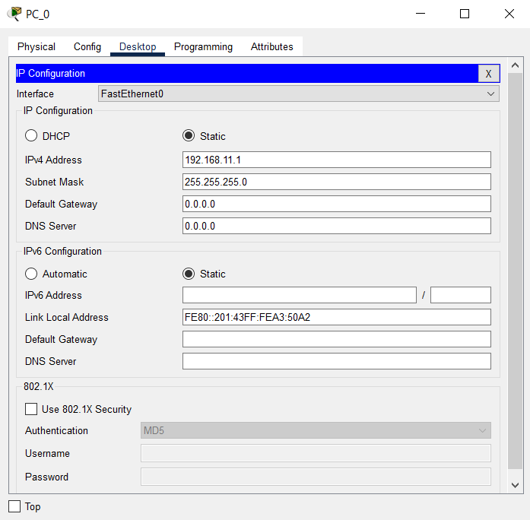

* **Ip chosen: 192.168.11.1**
* **For subsequent pc 192.168.11.2 and so on**
* **192.168.11.1: First PC of Bus Topology**
* **192.168.12.1: First PC of Ring Topology**
* **192.168.13.1: First PC of Star Topology**
* **192.168.14.1: First PC of Mesh Topology**

**A Pc Terminal:**

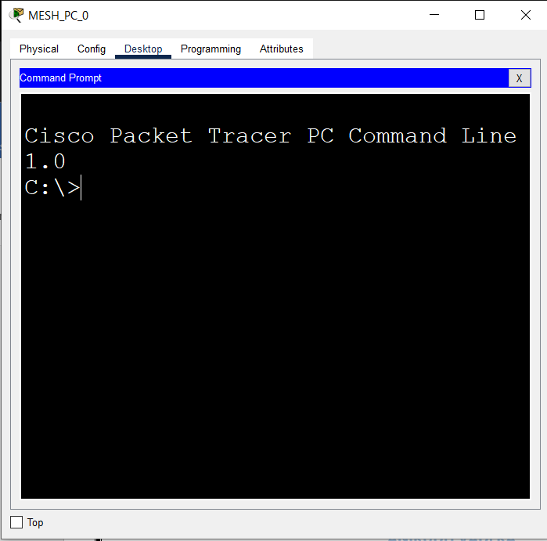

**Connection Types:**

**Bus Topology:**

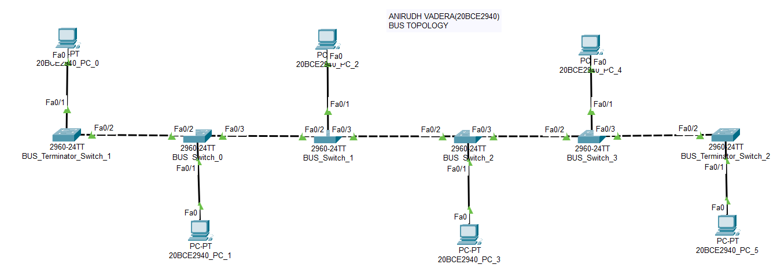

**IP OF PC0: 192.168.11.1**

**Name Format of a PC: 20BCE2940_PC_(PC_Number)**

**Name Format of a Switch: BUS_Terminal_Switch / BUS_Switch**

**SUBNETMASK OF PC0: 255.255.255.0**

**Number of PC’s Connected in the topology: 6**

**OUTPUT:**

**Pinging from PC0 to PC3:**

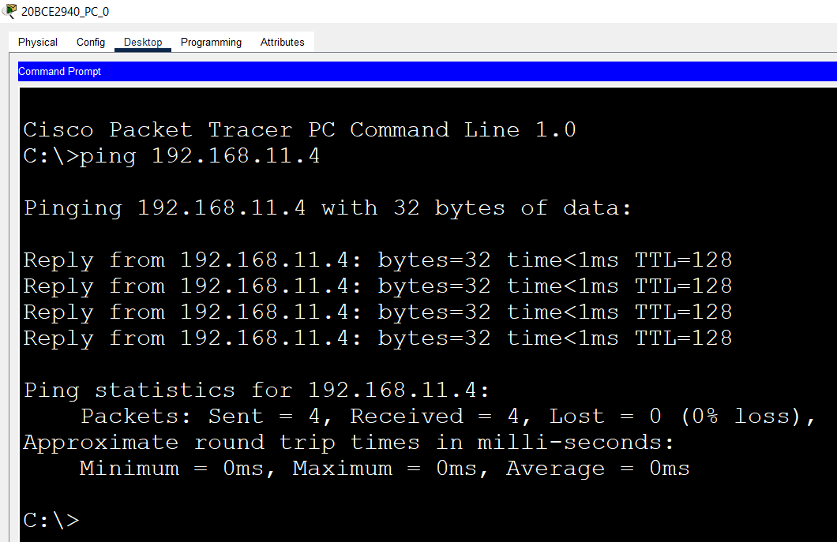

**Pinging from PC1 to PC2:**

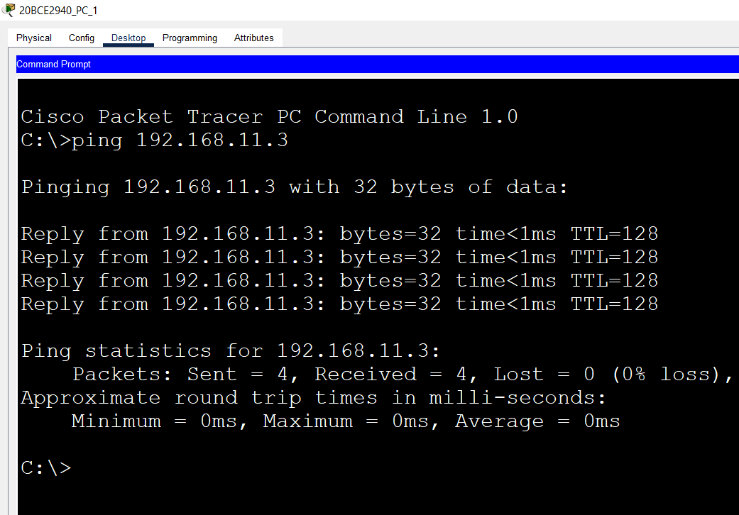

**Pinging from PC5 to PC7(This doesn’t exist in server so Loss should be 100%):**

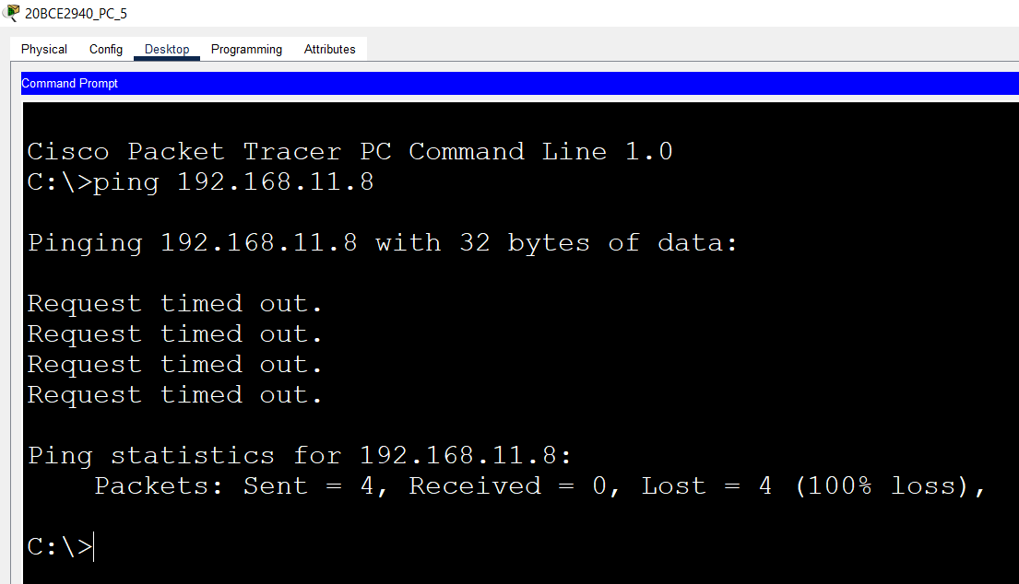

**Ring Topology:**

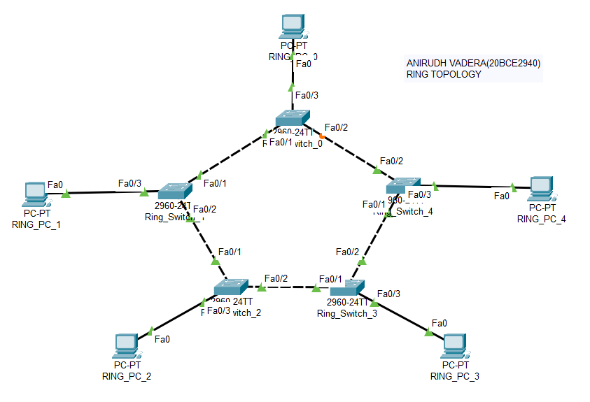

**IP OF PC0: 192.168.12.1**

**Name Format of a PC : RING_PC_(PC_Number)**

**Name Format of a Switch : Ring_Switch_(Switch_Number)**

**SUBNETMASK OF PC0: 255.255.255.0**

**Number of PC’s Connected in the topology: 5**

**OUTPUT:**

**Pinging from PC0 to PC3:**

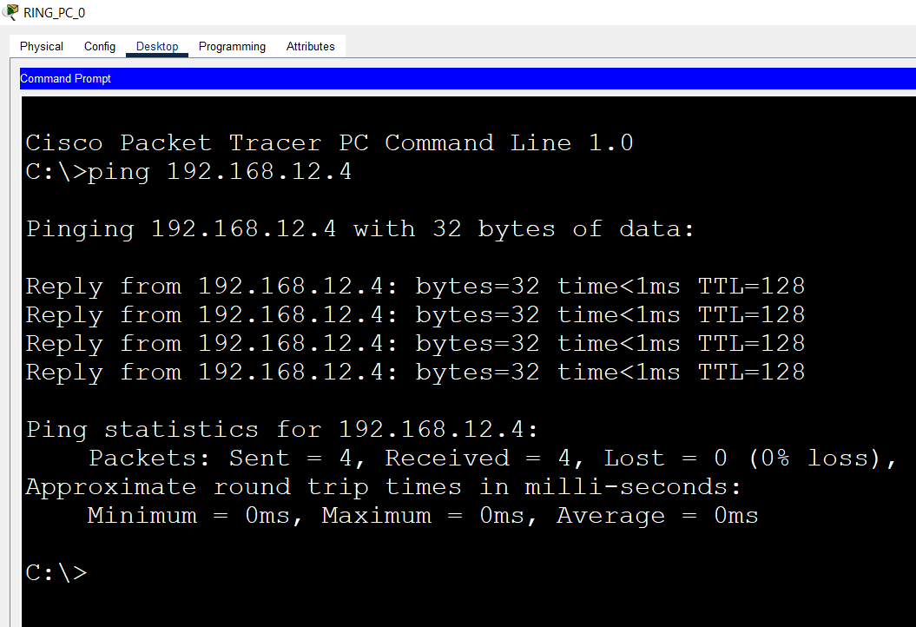

**Pinging from PC2 to PC3:**

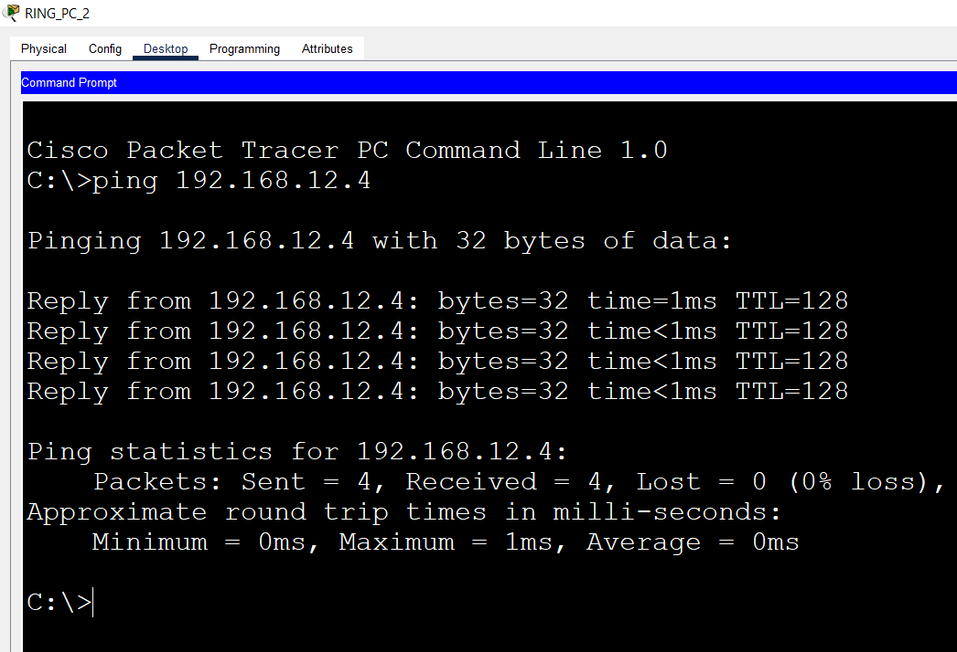

**Pinging from PC4 to PC7(This doesn’t exist in server so Loss should be 100%):**

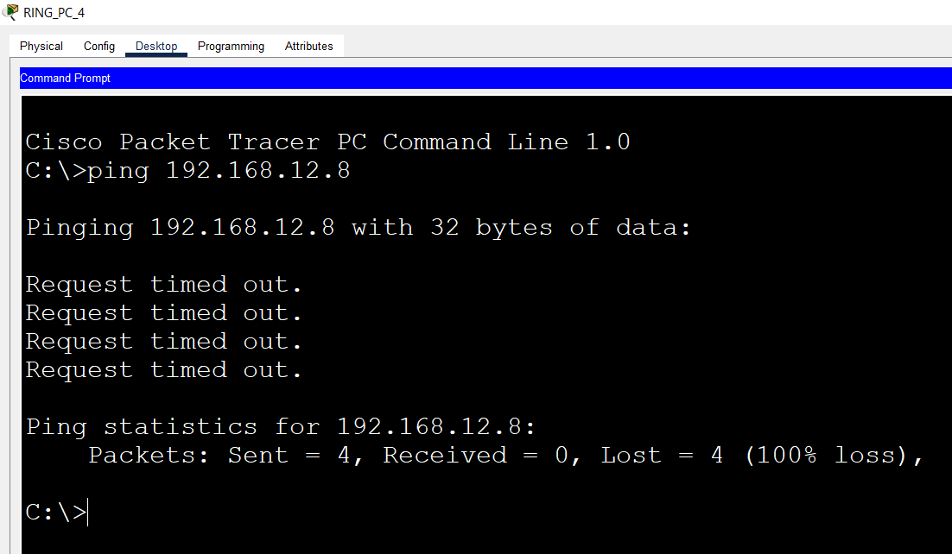

**Star Topology:**

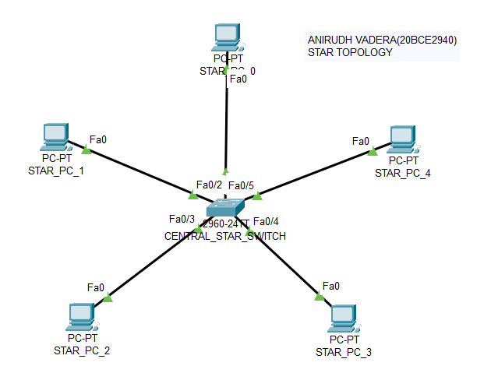

**IP OF PC0: 192.168.13.1**

**Name Format of a PC : STAR_PC_(PC_Number)**

**Name Format of a Switch : CENTRAL_STAR_SWITCH**

**SUBNETMASK OF PC0: 255.255.255.0**

**Number of PC’s Connected in the topology: 5**

**OUTPUT:**

**Pinging from PC0 to PC3:**

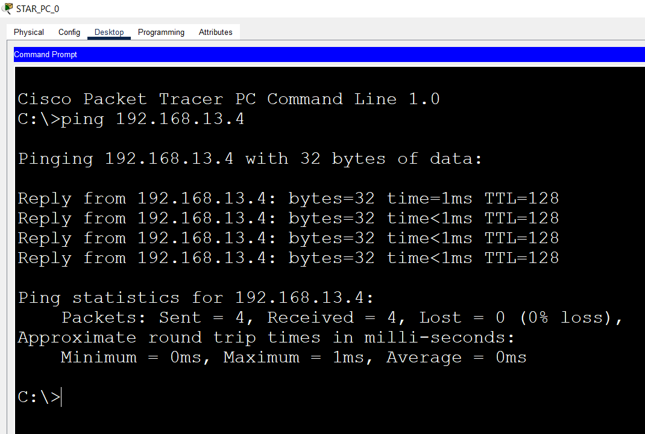

**Pinging from PC2 to PC3:**

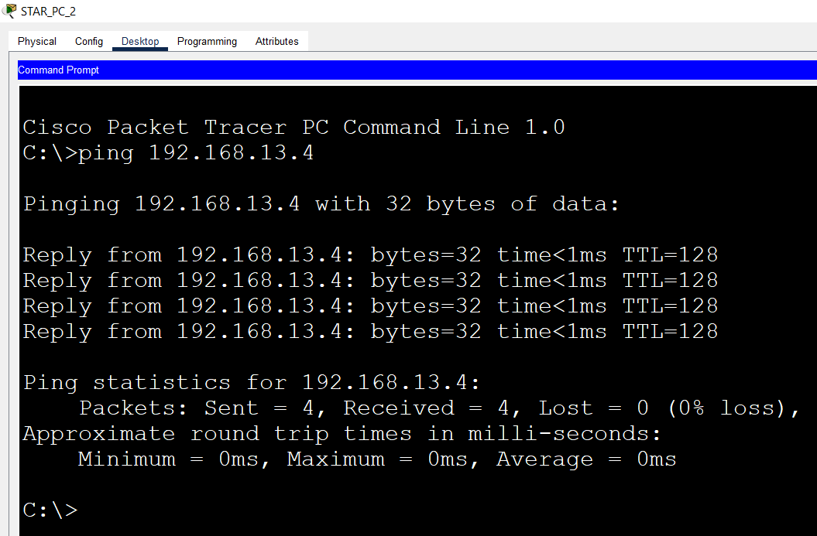

**Pinging from PC4 to PC7(This doesn’t exist in server so Loss should be 100%):**

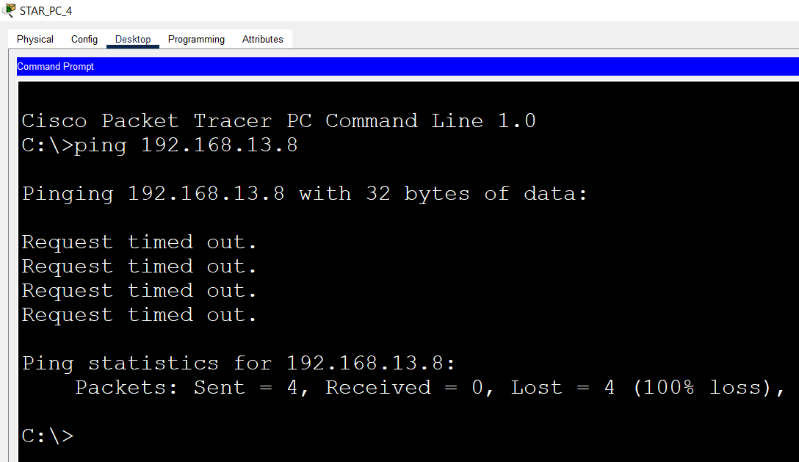

**Mesh Topology:**

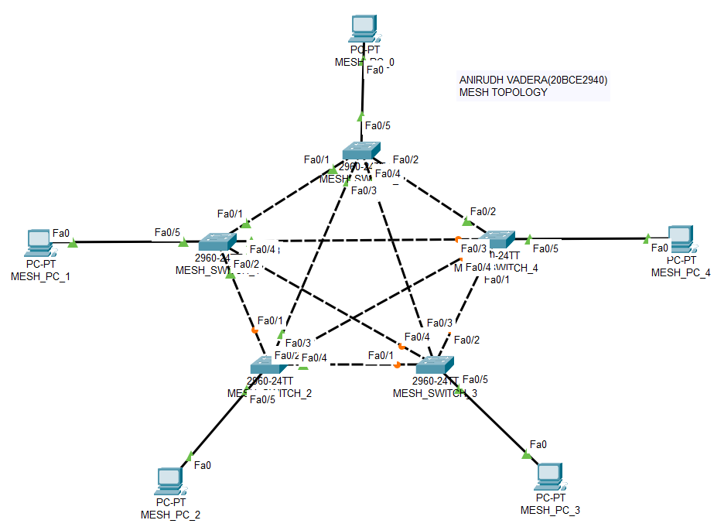

**IP OF PC0: 192.168.14.1**

**Name Format of a PC : MESH_PC_(PC_Number)**

**Name Format of a Switch : MESH_SWITCH_(Switch_Number)**

**SUBNETMASK OF PC0: 255.255.255.0**

**Number of PC’s Connected in the topology: 5**

**OUTPUT:**

**Pinging from PC0 to PC3:**

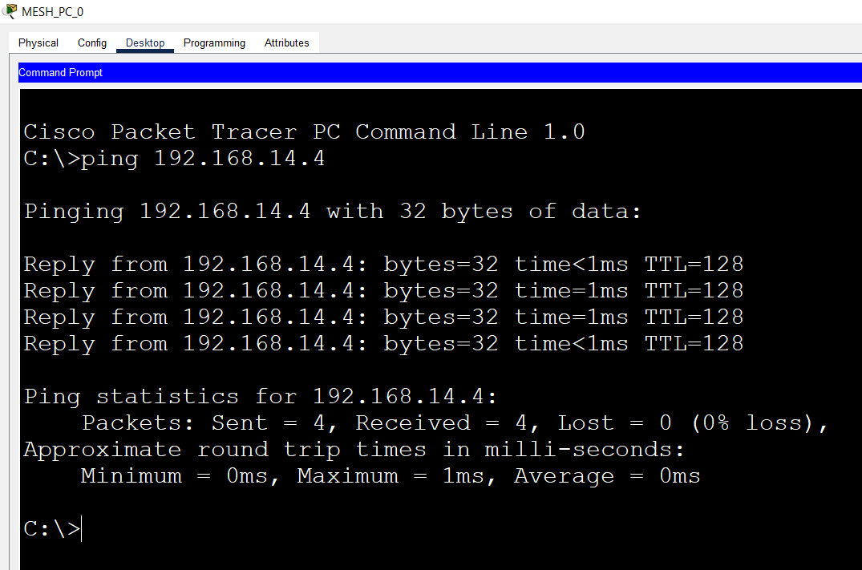

**Pinging from PC2 to PC3:**

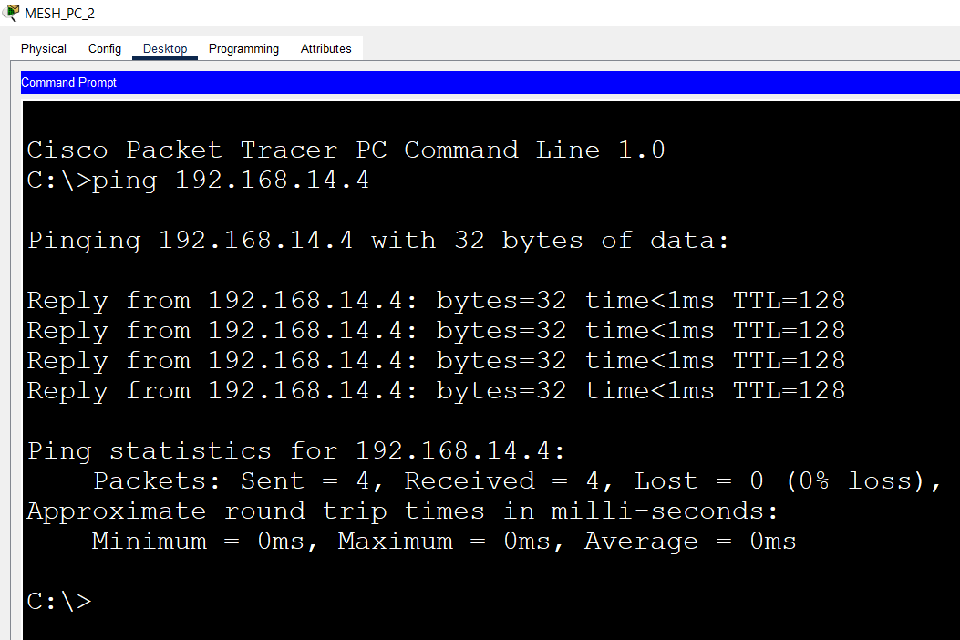

**Pinging from PC4 to PC7(This doesn’t exist in server so Loss should be 100%):**

